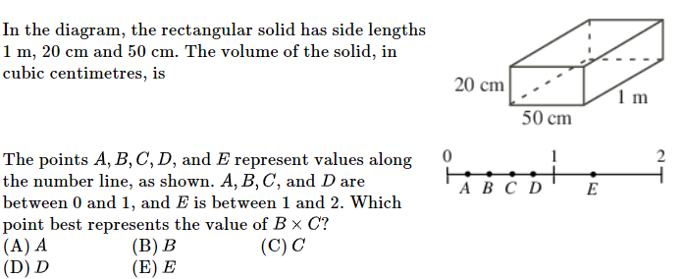

Create an equation to represent the situation and then solve using algebra!
Seventeen percent of a number is fifteen less than seventy percent of the same number. | Two-hundred percent of a number is eighteen greater than one-hundred twenty percent of the same number.
EQ: $17\% of n = 70\% of n - 15$  $0.17n = 0.7n - 15$ | EQ: $200\% of n = 120\% of n + 18$  $2n = 1.2n + 18$

Create an equation to represent the situation and then solve using algebra!
Seventy-one is what percent of ninety-five? | Twenty-three is what percent of two-thousand one-hundred?
EQ: $71 = x\% of 95$  $71 = \frac{x}{100}⋅95$ | EQ: $23 = x\% of 2100$  $23 = \frac{x}{100}⋅ 2100$

Create an equation to represent the situation and then solve using algebra!
Forty-nine is what percent of one-hundred ninety? | Four-tenths is what percent of nine-thousand?
EQ: $49 = x\% of 190$  $49 = \frac{x}{100} ⋅ 190$ | EQ: $0.4 = x\% of 9000$  $0.4 = \frac{x}{100} ⋅ 9000$

