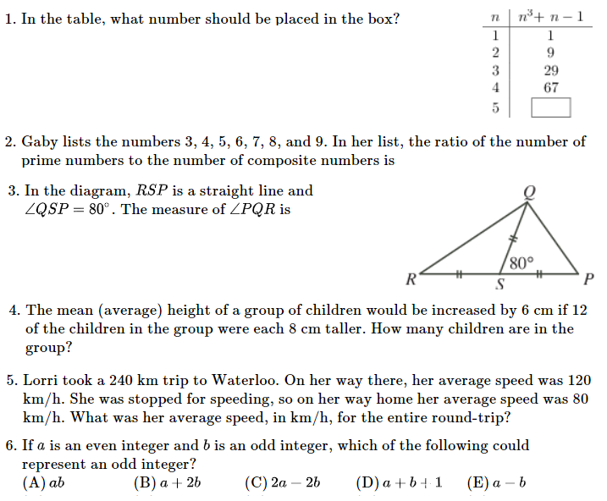

Create an equation to represent the situation and then solve using algebra! (Highlight for answers)
Thirty percent of a number is eighteen. | One-hundred fifty-five percent of a number is three thousand.
EQ: $30\% of n = 18$  $0.3n = 18$ | EQ: $155\% of n = 3000$  $1.55n = 3000$

Create an equation to represent the situation and then solve using algebra!
0.6% of a number is ninety-one. | Forty-eight percent of a number is twenty-two.
EQ: $0.6\% of n = 91$  $0.006n = 91$ | EQ: $48\% of n = 22$  $0.48n = 22$

Create an equation to represent the situation and then solve using algebra!
Seventeen percent of a number is fifteen less than seventy percent of the same number. | Two-hundred percent of a number is eighteen greater than one-hundred twenty percent of the same number.
EQ: $17\% of n = 70\% of n - 15$  $0.17n = 0.7n - 15$ | EQ: $200\% of n = 120\% of n + 18$  $2n = 1.2n + 18$

